Products

* milkfish (*bangus*) cultivation and processing, livestock raising, fish paste processing (*bagoong*), and others. Income in the Ilocos provinces or northern portion mostly come from cultivating rice, tobacco, corn, sugarcane, and fruits; raising livestock such as pigs, chicken, goats, and carabaos (water buffalos)

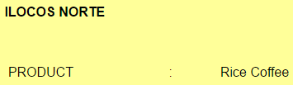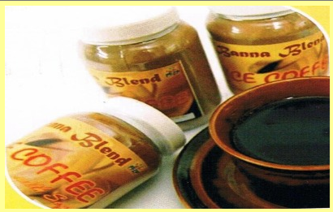

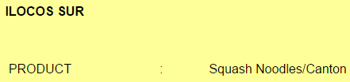 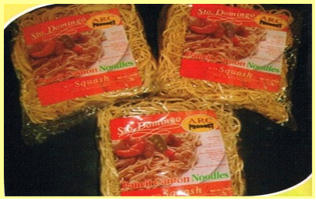

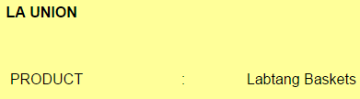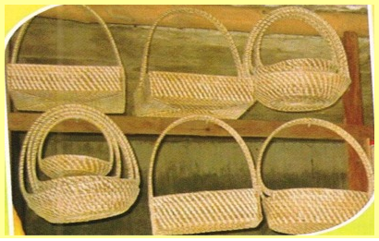

 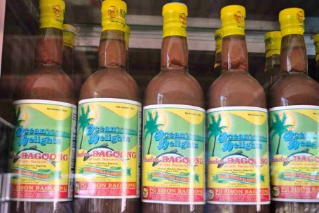

Prominent People

* [Elpidio Quirino](https://en.wikipedia.org/wiki/Elpidio_Quirino) — sixth President of the Philippines
* Ferdinand Marcos - 10th President of the Philippines.
* Fidel V. Ramos - 12th President of the Philippines
* [Gabriela Silang](https://en.wikipedia.org/wiki/Gabriela_Silang) — revolutionary leader best known as the first female leader of a Filipino movement for independence from Spain
* José Burgos — priest and one of the martyrs of [Gomburza](https://en.wikipedia.org/wiki/Gomburza" \o "Gomburza)
* [Pedro Bucaneg](https://en.wikipedia.org/wiki/Pedro_Bucaneg) — poet, and the "Father of Ilocano literature"
* [Leona Florentino](https://en.wikipedia.org/wiki/Leona_Florentino) — poet in the Spanish and Ilocano languages, and the "mother of Philippine women's literature"
* [Isabelo de los Reyes](https://en.wikipedia.org/wiki/Isabelo_de_los_Reyes) — politician, writer and labor activist in the 19th and 20th centuries, and the "Father of Filipino socialism" and unionism